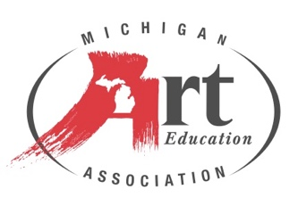

**2025 MAEA Art Educator of the Year**

**2025 MAEA Elementary Art Educator of the Year**

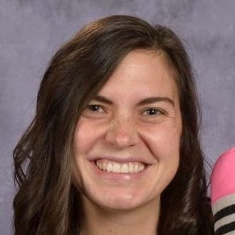Emily Miller has been an art educator for ten years. She graduated from Grand Valley State University’s art education program. While teaching elementary art in Rockford Public Schools, Emily continued on to receive her Master’s Degree in instruction and curriculum and teaching certificate in elementary education. Emily is now teaching young fives, kindergarten, and first grade art, focusing on getting her students excited about creating through learning about different elements of art and artists of the past and present.

When Emily is not teaching, she is busy volunteering somewhere in Grand Rapids. Emily has been involved at Grand Valley State University since graduation. Emily became president of the GVSU College of Education Alumni Network in 2015 and was on the GVSU Alumni Board of Directors from 2016-2023. In 2018, Emily began volunteering with Grand Rapids Festival of the Arts on the youth art committee. Since then, she is now the chair of the Youth Art and Communications Committee and is also on the Operations Committee and the Board of the Directors for Festival. If there is any time left, Emily may be found creating colorful chalk drawings or murals or teaching art at art organizations in West Michigan.